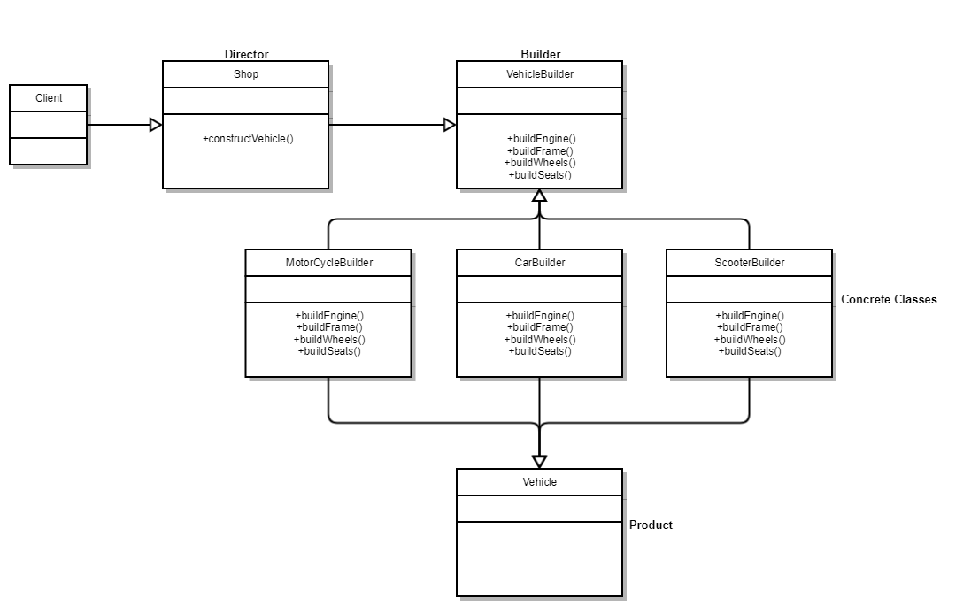

This is an example of using the builder pattern on vehicle. It works by having the client make a request to the Shop (Director) for a vehicle object. For example, if the request was for a car. The shop class would then process this, requesting the Vehicle Builder (Builder) class to construct a car object. The Builder class would then call CarBuilder (Concrete) class which would use the Builder’s abstract methods to create a car object. And finally, the Vehicle (Product) is the newly created car (Vehicle) object.

**Director –** Use’s builders abstract methods to create a Vehicle object.

**Builder -** The Vehicle Builder class provides abstract methods to the concrete classes.

**Concrete Classes -** The main purpose of these concrete classes is creating a vehicle object which enable it to be retrieved once constructed.

**Product –** The created Vehicle object